**Logical reasoning (set 2)**

**Company name: capgemini No. of Question: 16**

**1:** If in a code language 'DOUBLE' is written as 'LWYFVO', how will 'MASTER' be written in

the same language?

1. NZHGVI
2. ZNHGIV
3. ZNGHIV
4. None of these

**Answer :** option c

**Solution :**

**Opposite letters**

AS

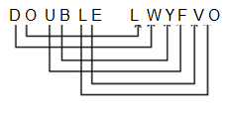

Similarly,

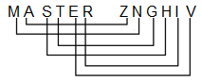

**2:** In the following question, select the option which can be placed at the sign of question mark

(?) from the given alternatives.

CYF, EWI, GUL, ISO, ?

1. IOL
2. KPM
3. KPL
4. KQR

**Answer :** option d

**Solution :**

Clearly,

1st letter C +2 E +2 G +2 I +2 K

2nd letter Y -2 W -2 U -2 S -2 Q

3rd letter F +3 I +3 L +3 O +3 R

So, missing term = KQR

**3:** If P means ‘division’, T means ‘addition’, M means ‘subtraction’ and D means

‘multiplication’, then what will be the value of the expression?

52 M 12 D 28 P 7 T 15

1. –30
2. –19
3. 19
4. 45

**Answer :** option c

**Solution :**

52 – 12 × 28 ÷ 7 + 15 = 19

**4:** DIRECTIONS: The second figure in the first unit of the problem figures bears a certain

relationship to the first figure. Similarly, one of the figure in the answer figures bears the same

relationship to the first figure in the second unit of the problem figures. You have to select that

figure from the set of answer figures which would come in the place of question mark (?)

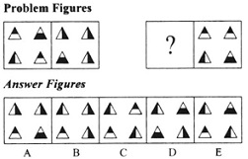

1. A
2. B
3. C
4. D

**Answer :** option b

**Solution :**

Here; in problem figure if 1st part(triangles) is horizontally shaded than second will be vertically

shaded and vice versa.

**5:** DIRECTIONS: Find the water image of the object given in the question figure.

**monday**

**--------------**

1. yadnom
2. 
3. 
4. 

**Answer :** option d

**Solution :**



**6:** How many triangles are there in the following figure?

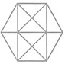

1. 20
2. 24
3. 28
4. 32

**Answer :** option c

**Solution :**

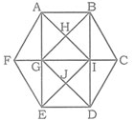

The triangles are:

∆FEA; ∆CBD; ∆FAG; ∆FEG

∆BCI; ∆CDI; ∆AFI; ∆EFI

∆BGC; ∆DCG; ∆AGI; ∆BIH

∆AGB; ∆ABI; ∆HAB; ∆HBI

∆HGI; ∆HAG; ∆GEI; ∆GED

∆IDE; ∆IDG; ∆JGI; ∆JDI

∆JGE; ∆JDE; ∆AIE; ∆BGD

**7:** Four positions of the Dice are given below. Which surface comes opposite to the surface 'C'?

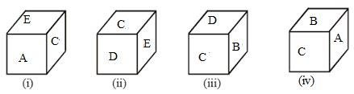

1. F
2. B
3. D
4. A

**Answer :** option a

**Solution :**

From dice position (i) and (iii), the letters of the adjacent faces to the face with letter ‘C’ are A, B, D and E.

Hence, letter ‘F’ will be on the face opposite to the face with symbol ‘C’.

**7:** Select an alternative from figure (1), (2), (3) and (4) which contain symbols to exactly make

the problem figure (X).

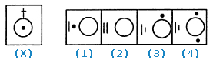

1. 3
2. 2
3. 4
4. 1

**Answer :** option a

**Solution :**

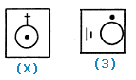

Figure (3) contains all the symbols of figure (X).

i.e., one point, one circle, one small line, one big line.

Hence, Option 1 is correct.

**8:** 5 friends are sitting beside the circle.

'A' sits between 'R' and 'D'.

'S' sits left to 'Y' and 'R' sits left to 'S'.

Who sits second left position of 'D'?

1. R
2. A
3. S
4. Y

**Answer :** option c

**Solution :**

5 person’s sitting arrangements are as follows:

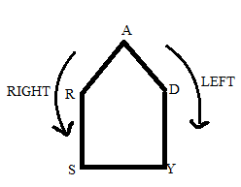

Hence, S is sitting second left position of D.

**9:** Find the missing number?

1, 1, 2, 2, 4, 6, 8, 22, ?, ?

1. 18, 60
2. 16, 64
3. 16, 86
4. 20, 76

**Answer :** option c

**Solution :**

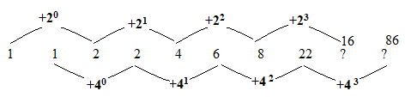

**10:** Which of conclusions can be concluded on the basis of given statements?

**Statements:**

No cat is fish.

All dogs are cat.

All fish are monkey.

Some monkeys are lion.

**Conclusion:**

Some lion being a fish is a possibility.

Any of the dog being a fish is a possibility.

Conclusion 1 is correct.

Either Conclusion 1or 2 is correct.

Conclusion 1 and 2 are both correct.

Conclusion 2 is correct.

**Answer :** option a

**Solution :**

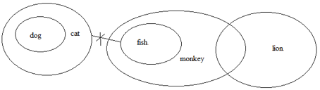

**11:** Find the odd word out?

1. LMNZ
2. DEGIK
3. DEFJ
4. TUH

**Answer :** option a

**Solution :**

L (12) + M (13) + N (14) +Z (26) = 65 (Not a perfect square number)

D (4) + E (5) +G (7) + I (9) + K (11) =36 (Perfect square Number)

D (4) + E (5) + F (6) +J (10) = 25 (Perfect square Number)

T (20) +U (21) + H (8) = 49 (Perfect square Number)

**12:** If "good speech by the prime minister" is coded as "by 6 good 5 minister 4 prime 3 speech 2

the 1" then find the code for "excited about holiday in the Netherlands"?

1. excited 6 about 5 holiday 4 in 3 the 2 Netherlands 1
2. about 6 excited 5 holiday 4 in 3 Netherlands 2 the 1
3. about 6 in 5 holiday 4 excited 3 the 2 Netherlands 1
4. holiday 6 about 5 excited 4 in 3 the 2 Netherlands 1

**Answer :** option b

**Solution :**

Words are arranged in alphabetic order and numbers in descending order.

**13:** Find the Third word according to the dictionary?

1. Traveler
2. Transverse
3. Trajectory
4. Translate

**Answer :** option b

**Solution :**

1) Trajectory

2) Translate

3) Transverse

4) Traveler

**14 :** Question is based on the following information.

A+B means that A is the father of B.

A-B means that A is the mother of B.

A$B means that A is the brother of B.

A@B means that A is the daughter of B.

A&B means that A is the sister of B.

M@C-N$K+G&Y

Find the relation between G and N?

1. Father
2. Uncle
3. Brother
4. Neice

**Answer :** option d

**Solution :**

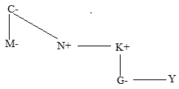

**15 :** If the letter of the word "DISPLAY" is arranged in alphabetical order from left to right.

How many letters will remain in the same position?

1. 2
2. 1
3. 3
4. 0

**Answer :** option b

**Solution :**

D I S P L A Y

A D I L P S Y

**16:** Which of the two conclusions can be concluded on the basis of given statements?

Statement

**Statement:**

a $≥b ≥c<d=e>f≤g$

**Conclusion:**

1) b e

2) b < d

1. Conclusion 1 is correct.
2. Both Conclusion 1 and 2 are incorrect.
3. Conclusion 1 and 2 are both correct.
4. Conclusion 2 is correct.

**Answer :** option b

**Solution :**

a

1) b e (×)

2) b < d (×)